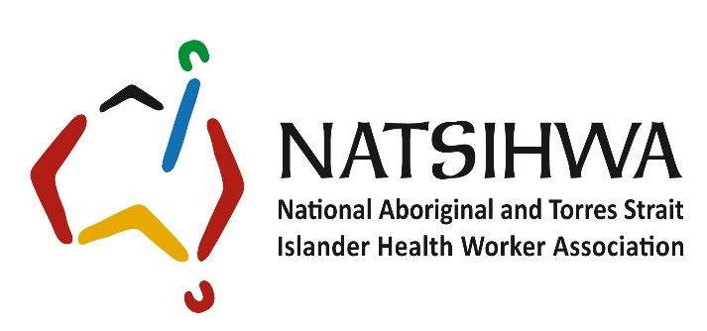

Job and Person Specification
Position: Executive Officer
Award: NATSIHWA Enterprise Bargaining Agreement
Level: Level 5 ($70,426 - $76,163 plus superannuation) pa
Appointment: Contract to 30 June 2022; extension maybe subject to funding and organisational requirements
Position Hours: Full time – 38 hours a week
Updated: October 2019

Job specification

Position summary
The Executive Officer is responsible for:
- providing administration support to the CEO;
- managing the CEO’s diary;
- undertake basic research and briefings of agendas and papers for the CEOs meetings
- Preparation for and taking minutes of the quarterly Board meetings and the NATSIHWA Annual General Meeting (AGM)
- undertaking the travel arrangements for the NATSIHWA Board and staff once travel approval is obtained;
- providing administration support on relevant projects;
- overseeing the IT requirements of NATSIHWA staff
- implementing and ensuring new employees undertake the NATSIHWA induction process and
- undertaking the monthly OH&S audit and ensure that OH&S compliance standards are in place.

Line management
The Executive Officer reports directly to the CEO and indirectly through to the COO.

Special conditions
- This is a Canberra-based position.
- All NATSIHWA employees participate in a formal performance development process.
- Out of hours work and interstate travel will be required on occasions.

Primary responsibilities
- Manage the CEO’s diary; confirm appointments and meetings for the CEO, or their delegate, and ensure their attendance or provide formal apologies where required
- Provide executive support to the CEO in printing agendas, researching the information required by the CEO for the meetings; this could include sourcing background briefing papers from NATSIHWA staff prior to the meetings.
- Provide draft responses for the CEO to approve, to routine questions.
- Work with the CEO to develop rules for his mailbox and help manage the vast number emails which are received in the CEO’s In-Box
- Forward mail from the CEOs mail box to other NATSIHWA staff for them to provide responses for the CEO or for them to respond directly to the email.
- Prepare Board meeting papers where directed, in liaison with the CEO and other relevant staff for NATSIHWA Board meetings. Take minutes for the Board Meetings and AGM
- Manage all travel arrangements and reimbursements for the CEO, Board and other staff members where required.
- Assist with arrangements in organising NATSIHWA meetings, forums and functions.
- Provide secretarial support to the weekly staff meetings and ensure follow-up of action items for the next meeting.
- Responsible for mail collection and recording from the Mawson PO Box and despatch of mail from the office.
- Liaise with NATSIHWA external IT support on computer issues.
- File organisational documents in accordance with the information management policies, procedures and hard copy and electronic filing system.
- Provide reception duties including trying, ordering of stationary equipment for the NATSIHWA office.
- Undertake any other relevant duties as directed by the CEO.
- Ensure appropriate OH&S compliance standards are in place for NATSIHWA Office.

Person specification

Essential criteria

1. Personal abilities/aptitudes/skills
- Demonstrated ability to work with Aboriginal and Torres Strait Islander peoples, respecting cultural values and ways of doing business.
- Demonstrated ability to communicate effectively and respectfully, both verbally and in writing, with all levels of people from both within and outside the organisation.
- Demonstrated ability to deal appropriately with sensitive issues and maintain a high level of confidentiality and diplomacy at all times.
- Demonstrated ability to appropriately exercise initiative and judgement, and make sound and timely decisions while adhering to organisational policies and procedures.
- Demonstrated ability to work autonomously and as a member of a team, and recognise and resolve conflict.

2. Experience
- Experience in working with Aboriginal and Torres Strait Islander peoples and organisations
- Experience in arranging meetings/functions, responding to phone or email inquiries, making travel arrangements, filing and records management.
- Experience in the use of information technology, including word processing packages, electronic mail, databases and spread-sheets.

3. Knowledge
- Knowledge and understanding of the current issues impacting on Aboriginal and Torres Strait health and wellbeing from both an historical and political perspective.

4. Qualifications
- A Certificate III in Business or Administrative Services or a higher relevant qualification.

Selection criteria and process
In applying for this job we need you to provide two documents:
- An up to date Curricula Vita (CV) that includes the names and contact details for two referees from recent positions you have held – please be aware that we may request a written reference.
- A maximum 3-page letter outlining your response to the following five questions that demonstrate
  - your ability to perform the job
  - how you meet the all of the essential and any of the desirable criteria in the person specification:
A copy of the NATSIHWA Executive Officer role description can be found at: https://natsihwa.org.au/jobs-natsihwa
Aboriginal and Torres Strait Islanders people are strongly encouraged to apply.
- What work have you done in Aboriginal and Torres Strait Islander contexts? How does it relate to this position?
- What experience have you had in providing executive assistance to a senior manager in an organisation within the not for profit sector? How will this be valuable to NATSIHWA?
- What knowledge do you have in organisations within the not for profit sector, including providing secretarial support to meetings, and reviewing occupational health and safety matters to ensure compliance?
- How would you describe your experience, skills and confidence in using information technology, Microsoft products and managing diaries?
- What values and commitments do you hold in working independently and in a team as part of a small organisation?
Once you have completed your letter of response and attached your CV please forward onto Julie Guest at eo@natsihwa.org.au

If you require further information please contact Julie on (02) 6221 9221.

